Multi Class Sound Classification using
Machine learning

Abstract
Deep learning is becoming more and more popular as a way to avoid laborious pre-processing of data. Various pre-processing cannot only improve the prediction of prediction but also constitute a fascinating topic. The sound classification problem is such a situation. Sound classification is an evolving research area with a variety of applications for large-scale, content-based multimedia indexing and retrieval. In this paper, we concentrate on the cross-industry standard process for data mining (CRISP-DM), CRISP-DM is an open, freely usable data mining process. By taking various sound samples through the data processing stage, the spectrograms are obtained, and the sound is classified according to the frequencies in the spectrograms. Besides this, different machine learning classification algorithms is used such as random forest classifier, k-nearest neighbor (K-NN), support vector machine (SVM) and Artificial neural Network (ANN) are applied to model and compared at final stage. Out of which ANN classified sounds label with higher accuracy of 89.93%
Keywords: CRISP-DM, sound classification, random forest, K-NN, SVM, ANN

I. Introduction
The sound consists of random noise and regular audio signals. A regular signal is an analog signal that is connected to a periodic change. The audio frequency that human hearing can feel is 20 Hz~20 kHz, and the sound signal below 20 Hz or higher than 20 kHz belongs to multimedia information audio. Sound waves are a timely extension of the signal, and at each point in time, the current signal depends on the past. In the time domain, the continuous amplitude of the signal age is composed. In the frequency domain, the signals are represented by different frequencies. The conversion from time domain to frequency domain can use Fourier transform, according to the time and whether the signal itself is continuous or discrete, there are different types of Fourier transform, in the "real world", using discrete Fourier transform, because when dealing with digitized signals, it actually means virtual [1]. Accurate classification of sound signals has been applied in the fields of audio monitoring, hearing aids, hospitals and so on. Urban sound classification faces many difficulties. For example, the sound source generation mechanism is different, there is a possibility that there is noise in the source (such as the sound of air conditioner or engine), the urban auditory scene can represent almost unlimited configuration, lack of voice, etc. [2]. To the advanced structure and so on and classifying city sounds is a challenging task.
Based on the above, the research question of this report is: To what extent proposed machine and deep learning algorithm can accurately classify different sources of sounds?
The motivation for this paper is to process the data from different sources, and then standardized that data to audio or image data to finally obtain the spectrogram which further classify the sound. Spectral separation, spectral distribution, harmonicas, onset and offset, correlation amplitude and frequency variation, spatial separation, and time separation are all auditory features that play a key role in auditory grouping [3].
The contribution of this paper is to propose and compare a new hybrid model to accurately classify sounds. The remaining of the paper is structured as follows: Section 2 the literature review about the sound classification methods and Section 3 is the background of the dataset; Section 4 is the model; Section 5 presents the results and Section 6 is the conclusion and future work.

II. Literature Review
Sound is generated by different frequency signal with related to time. Feature extraction showed important classes out of which 12 significant classes were chosen by Pearson correlation co-efficient. 7 optimized classes was designed as some of 12 classes failed to show any instances after classification technique. Higher accuracy was achieved in classifying sounds of 7 class model by ANN, SVM after PCA [4]. Spherical k-means was used for feature engineering on noise complaints dataset which was classified by Random forest (RF) Algorithm in [2]. The results evaluated by 10-fold cross validation showed greater accuracy in classification of stationary noise and non-stationary noise. Multi-instance multi label (MIML) approach was used by converting number of instances to classify bird sound from pool of different sounds in [5]. Extracted features like mask descriptor, profile statistics and histogram of gradients (HOG) were used to prepare baseline classification model Ensemble of classifier chain (ECC) ECC-RF against proposed MIML-k-NN, MIML-SVM, and MIML-RBF models. Results showed that MIML-k-NN outperformed every model when it comes to multi instance classification. The identification of background noise was done by classification model in [6] by extracting pitch, zero crossing rate (ZCR), Mel Cepstral co-efficient (MFCC), spectral flux (SF), spectral centroid (SC) and short time energy later tested by various classification algorithm like SVM, RF, DNN out which RF achieved higher accuracy in predicting background noise in less time followed by SVM and DNN. [7] used MFCC and Linear predictive cepstral co-efficient (LPCC) techniques to extract features of sound from spectrogram images generated by audio signal of different objects to classify amateur drone out of it. Then extracted features were passed through SVM algorithm showed that MFCC-SVM model has the highest accuracy of 97% in classifying drone object from sound data compared to LPCC-SVM accuracy of 75%. The dependency on feature extraction was contradicted in [8] where heart sounds classification was done from intensity map using CNN and Soft max regression (SMR). The intensity map was generated on 48x48 square matrix by using features of heart beats. The obtained results clearly indicated that CNN outperformed SMR by automating feature extractions process by adjusting its hyper parameters to accurately classify between abnormal and normal heart beats from heart sounds. Performance of CNN is revived and higher accuracy is achieved if it is trained at initial stage with chromatic spectrogram image generated from sound data. 47 class of insect sounds was classified up to 97% in less time [9]. Evaluating results of [4] a combinational method was proposed for classification of animal sounds in [10] using CNN for extraction of features then feature transformation by LDA and then classifying it by kernel SVM.. CNN extracted sound features of insect anuran and birds and trained dataset. The classification accuracy was in range of 70 % to 97% by SVM after LDA. Image based sound classification approach using CNN achieved 20% higher accuracy than using normal classification of texture audio data of heart sounds [11]. A scalogram image obtained from heart signal was trained by CNN model and compared with SVM model obtained from processing audio data. A test was conducted in classifying lung sounds generated by sonar and stethoscope to fitness [12]. The extracted features of sound by Essentia library were later used to build classification model by boosted regression trees which served 85% accuracy in classifying patient’s class. On similar dataset vector auto regressive (VAR) was performed to build a spatial-temporal features model impacting sound which was later trained on SVM and Gaussian mixture model (GMM) for classification, out of which GMM yielded 85% accuracy in predicting label of class on basis of evaluating MAP and probability score [13]. Abnormalities in lung sound was classified using a Recurrent neural network (RNN), classifying 89% of class compared to GBM which showed only 53% accuracy [14].
Extracted significant classes of sounds of local area and global level were aggregated to form dictionary type model for classification. Local features were extracted using SVR and for global features Bayes law was used. Kernel density estimator (KDE) classified the sound from different source at higher accuracy. The results clearly show that dictionary of sound is directly proportional to classification accuracy [15]. Convolutional neural networks (CNN) have been successful in the processing of speech and music signals, especially in the classification of environmental and urban sound sources. By extending CNN and introducing environmental sound classification (ESC) problems, [16] have achieved better results than CNN and the largest collections and other Advanced method. A similar kind of light weighted dilated CNN was proposed in A real-time hierarchical classification method that can distinguish environmental sound signals is developed by [14] which consists of three levels. Calculating the effective features according to needs at different levels of the hierarchy is the main feature of the method. Compared with the traditional part of the class methods, [17] has higher classification rate and computational efficiency. The only problem was if the dilation frame increases its leads to loss of information, because of inefficiency of CNN kernel to engulf all information and changing size of training data. To counter these a Light weighted dilated CNN (LD-CNN) modelling was done in [18] which classified various sounds in minimal time with loss of 1% to 2% accuracy by compressing same model size up to 50 times. The severity and wheezing of asthma patients were classified using spectral integration (SI) characteristics. [19] using the overall ensemble (ENS), support vector machine (SVM) and k-nearest neighbor (KNN) methods to classify asthma severity levels in the group, the results show that the best positive predictive value (PPV) for mild, moderate and severe samples is 95 % (ENS), 88% (ENS) and 90% (SVM). Using the Lanczos kernel and deep neural network (DNN) classification to reduce the spectrogram image features (SIF) function, the results shows that although MFCC, MPEG7 and Gabor get better continuity under noise, the available SIF technology provides results to some extent [20]. According to the polysomnography data, the zero-crossing rate and the formant of the sound signal classify the breathing and snoring segments, [21] first calculated the number of zero crossings, the logarithm of the signal energy and the first formant and then pass that through the Fischer linear discriminant method. The obtained three-bit feature is transformed into a one-dimensional space, and finally the Bayesian threshold is applied to the transformed features to classify the sound segments as snoring or breathing.
Summary of literature review:
After analysis of literature review, it is clear that features such as ZCR, MFCC, SF, and SC are effective for sound classification and its effectiveness increases when combined with algorithms such as SVM, RF, ANN, CNN, k-NN and DNN. Besides, The Bayesian threshold is applied to the transform feature, KDE, and GMM also has a high accuracy for sound classification. These gives hinted direction to study the area of sound classification by four algorithm SVM, CNN which is mostly used and k-NN, RF which is least used.

III. Methodology
Cross Industry standard process for data mining (CRISP-DM) is term used in the project development by extracting informative data patterns from qualitative data by using automated tools for business process [22].The dataset contains more than 8K rows of urban sounds from different objects, animals under 10 labels. Considering literature review section the same procedure of first feature extraction and machine learning algorithms for classification is applied on dataset. Significant features were known by performing correlation test by SPSS and statistical tool Python was used to prepare two sound classification model for comparison purpose and deriving pattern which led to accuracy in classification of labels. The procedure of CRISP-DM are shown below
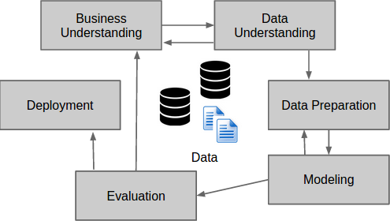
Fig 1: CRISP-DM Process

I. Stage1-Business understanding
The main objective behind developing this project is to understand the complex sound classification which indirectly helps in setting business goals like building efficient supportive sound technologies for various devices. The success of project entirely depends upon reaching data mining goals like to which extent classified features can be predicted accurately and do same classified features can be predicted from global level dataset.
II Stage 2- Data Understanding
The dataset used in the project is obtained from site www.urbansounddataset.com. The dataset contains 8732 rows of WAV format data in numeric form under 10 classes of AC, horn, children, dog barking, street music, gunshot, engine, siren, jack hammer and drilling sound which is recorded in environmental condition. Time feature is about start and end time of sound recording. Ratings features shows whether the sound has background noise or foreground noise. Slice file name features contains numeric information about timely occurrences of class sound in selected segmented dataset by number of instance.

III Stage 3- Data Preparation
1) Feature engineering
Feature engineering is process of refining rough dataset and building valid features out of it as feature labels in predefined cut-off time. Automated feature library is used to encompass every problems of dataset so that various prediction problems can solved at initial stage and even if there is any new variables is added in future its has no issue with class prediction because it uses same predefined set codes of library for feature engineering. Coding is done in python using feature library to relate the data to each other and after churning of relational data multiple valid features are extracted out of it which is having properties of primitive features.

2) Data Cleaning
All values are in numeric form so no need of conversion and assigning categorical values to dependent variables. The missing values are imputed with random forest function and to make consistent dataset without any biased value so that model optimization can be achieved easily.

3) Feature scaling:
Some of the features have high variance in numeric data than other features so feature scaling is done to reduce variance by normalizing data to best equated line and to same value so that Machine learning can optimally understand pattern of data.

IV Stage 4 – Data Modelling

1) Feature Selection:
If linear relation is known between different features it can help in optimizing model by avoiding over fitting.

2) Training set and test set:
The dataset is divided into 75/25 ratio of training set and test set respectively by following benchmark set by researchers. The training set is allotted with maximum data after split so that machine learning algorithms can perform all operation on all time variance data and derived results are used to check accuracy on test data which give predictive models.

3) Classification model
Four classification algorithms are proposed in this project out of three are supervised and one is unsupervised machine learning, considering research done in this field by other researchers to understand and compare predictive classification model with aim to achieve high accuracy.
k-Nearest Neighbour (k-NN)
k-NN is to calculate the distance between the input feature and the feature points in the training set, and then select the smallest k values ​​among the distances and predict the classification of the input instance according to the category of the data points corresponding to the k values. Distance metrics, classification decision rules, and k-values ​​are three basic features. K-NN does not require training, especially suitable for multi-classification problems. k-NN takes handles distorted noise dataset robustly in fast computational time[5].

Random Forest classifier (RF)
Random forest is unsupervised ensemble learning technique consist of various classification algorithm performing parallel operation on same dataset. Random forest consist of number of decision trees voting in favor of event occurring and not occurring as a prediction by splitting dataset according to significant features. The RF method simply evaluated by the size of trees in supporting the significance of predictor variable related to dependent variables by using the highest ranking feature in order without using correlation. It is robust classification method because it avoids randomness in data plus errors size are reduced due to usage of significant features for predicting yes or no area for variable. RF compared to k-NN handles outliers and noise easily and has no effect in predicting new instances. The best part of RF is to calculate proximity of data of test set so that unwanted data can be replaced or removed [23].

Support vector machine (SVM)
The SVM kernel based function deals with classifying non-linearly separable data points by mapping it into higher dimensional space to obtain a linearly separable vector points from it for classification [24]. The mapping is done by dividing the space as a category by optimal line known as hyper-plane which is decided by SVM. The two vector points having maximum distance from hyper-plane are chosen as support vectors which runs the whole algorithms and divides the plane as negative hyper-plane having events that failed to occur and positive hyper-plane is about instances that occurred. The algorithm performance remains same even if the all variables in category are changed because whole responsibility of classification is supported by that two supporting vectors which indirectly supports decision boundaries. Because of such dependency on extreme vectors to classify category of variables SVM is one of the risky algorithm, contradicting to it the related work section shows it one of the mostly used and the one to achieve reasonable high classification accuracy in field of sound source classification.
Artificial Neural Network (ANN)
ANN consist 3 layers for intercepting the data known as Multi-layer Perceptron which consist of input layer, hidden layer and output layer. The input layer Independent data points are weighed and averaged and then passed through Neurons (Hidden layer) for training process after which it act as input for output layer from which categorical prediction is done. The hidden layer is masked with rectifier function to increase non linearity in our model so that model can be trained and improves its learning process and for output layer sigmoid function is used to show non linearity. ANN provides facilitates predicting class significance by using backward propagation method which follows back process like starting from output layer and ending at input layer. ANN automatically adjust its hyper parameters for optimizing models. Since ANN has property of automatic feature extraction it can explore hidden relationship in data which deepens understanding of complex data and make process faster and reliable [25].

Justification for not using other classifiers
The classifiers like Naïve Bayes were not considered because our data is non–continuous and since Naïve Bayes only show categorical answer like whether the sound occurred or not on probability basis. On the contrary SVM, RF doing class classification so unnecessary usage of Naïve Bayes is avoided for just event classification. Decision tree classification is replaced by higher version of its known as Random forest which can extract significant features and classify multiple instance at same time. Logistic regression only works with linear model and sound data in these project is non-linear. CNN works on image data for feature extraction and the project scope includes deriving accuracy from audio data.

IV. Proposed Model

In this paper, the data is classified as following steps. At first the feature engineering is done to derive important features as exploratory data analysis. The preprocessing of data is done at next stage which includes significant features data as training and test devoid of the noise data. Then the model is passed through classifier like SVM, K-NN, ANN and RF classification algorithms are used to classify and the results will be compared by evaluation.
In the end, machine learning models are used to evaluate by Precision, Recall, Confusion Matrix, Epoch vs. Accuracy and F1 score. The statistical tool python is used for performing machine learning algorithm because it has proper specific function library called librosa allotted only for audio data feature extraction, noise handling.
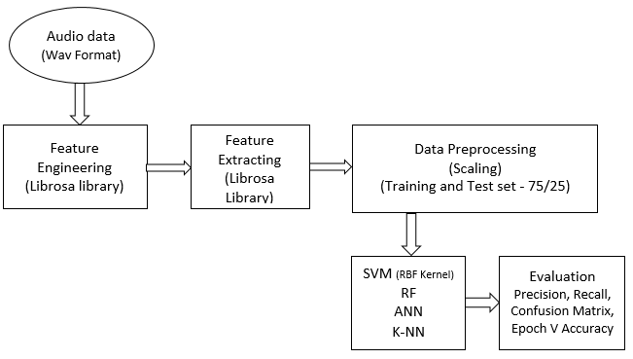
Fig 2: Hybrid Classification model

On basis of evaluation the best predictive classification model is proposed. Data exploration clearly show sound of the gunshot and car horn has minimum values.
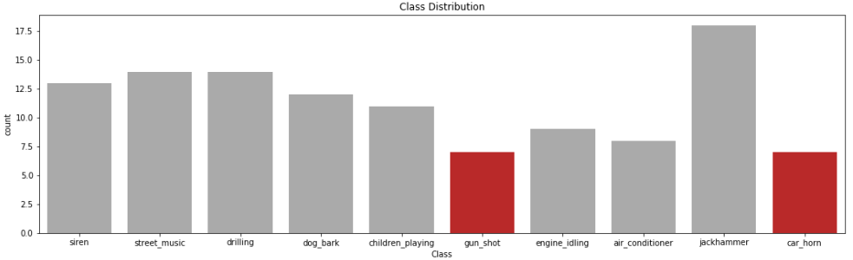
Fig 3: Data exploration

V. Stage 5 - Evaluation of models

The model accuracy is dependent on predicted variables outcomes in the boundary of prediction area which requires pre-set standard rule for interpretation for understanding the relation, significance of variables and initiates further analysis by changing format of data to get desired evaluation. As multi-class classification of sound is required in the project 10 cross validation is used as a base for evaluating accuracy of models by showing all true positive and true negative outcomes in diagonal form and rest are considered as false outcomes. The unbiased evaluation techniques to validate the accuracy of model are as follows

1.) Confusion Matrix
Performance of classification of observed value and predicted instances are showed in 2x2 square matrix form[26]. As the number of class increases so as size of matrix in equal form. The diagonal region of matrix represent the number of correct predictive instances and rest show the incorrect or fail predictive instances. Confusion matrix for these project is shown in form 10 cross validation format where each class prediction will be shown diagonally.
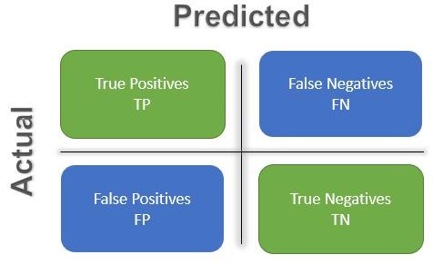
Fig 4: Confusion Matrix

2) Accuracy
Accuracy of model is calculated by ratio of corrected predicted outcomes to total predicted variables. Accuracy totally depend upon the failure to classify the correct variable which lead to increase in error rate [26].
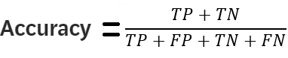
3) Precision
Precision evaluates classification performance by calculating the correctly the positive predict instances out of the total positive instances. Precision function is to show accuracy of that predictive model in accurately predicting the instances [26].
Precision = TP/ (TP+FP)

4) Recall
Sensitivity of model is defined by Recall value which indicates response of model to the true and false classification. Recall calculates the number of true values goes undetected by model at the time of true classification and similarly for false values [26].
Recall= TP/ (TP+FN)

5) F1 Score
F1 score is harmonic mean value obtained by using both precision value and recall value. Since equal weight is given to both precision and recall value by F1 score the results obtained are uncertain [26]. The model with reasonable F1 score means accuracy of model in precisely predicting true outcomes and not missing true outcomes.
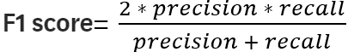

6) Epoch vs. Accuracy
Epoch is iterative process of neural network through which complete dataset is passed multiple times by dividing dataset into set batch wise, so that model can be optimised by training weight of data simultaneously. Epoch process is plotted on graph against accuracy obtained from test set which show fitting of model. Iterative process only stops when neural network achieves satisfaction rate of accuracy by epoch like changing models from under fitting to optimum models. It can be evaluated from assessing graph as shown below [27].

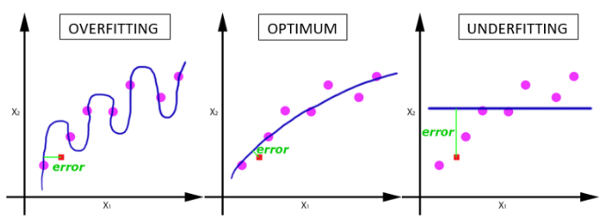
Fig 5: Epoch vs. Accuracy graph

VI. Experimental Results

The experiments was done in the direction to classify maximum class accurately out of raw dataset therefore comparative study is done to validate the result and check accuracy of different classification technique related to different sounds. The results obtained are as follows for supervised machine learning Classifiers like SVM, k-NN, and RF the k-NN achieves similar accuracy compared to SVM but precision rate is higher by 3% means it classify true prediction correctly according to events. The random forest classifier achieves a slightly 5% less accuracy compared to rest two classifiers.

Models | Accuracy | Precision | Recall | F1 score
SVM | 85.35 | 0.84 | 0.86 | 0.85
k-NN | 89.77 | 0.89 | 0.88 | 0.88
RF | 84.40 | 0.83 | 0.84 | 0.84

Random forest classifier predicted 95% sound with precision of AC, engine idling, jack hammer class. 72% Sounds of Street music and car horn class were the least predicted by RF as just because of noisy data in that environment. But for same class of AC k-NN showed 98% precision accuracy and for jack hammer it has least precision of 99%. k-NN has least accuracy in classifying dog bark sound class but on environmental sounds noisy data had seemed to rarely affect the accuracy has it classified children sound and street music by 91% and 83% accurately. SVM has accurately classified jack hammer sound class with 100% precision and achieved a reasonably higher and similar accuracy as like RF but no match at any par to k-NN in classifying environmental sounds as it also show sensitivity to noise in class data by 74%. k-NN showed a sensitivity of 67% accuracy to gunshot sound class but still able to class 87% of sound of it. RF and SVM results has been straight forward to be interpreted as like the class which showed least recall factor showed the least precision. Except gunshot sound class which was classified by SVM only 73% accurately even when the recall was 92%.
After highly satisfaction result an unsupervised deep learning method was used to explore the field and check whether any further improvement can be proposed. The proposed unsupervised ANN accuracy in classifying multi class label showed 89.93% accuracy only fractional higher than the k-NN. The graph epoch vs. accuracy below clearly show the optimum curve of test and training model. Visualising the graph clears the understanding that as the weighted average of data is keep on increasing the accuracy of model is optimized by ANN as continuously working like learning and deriving a relation between the data points dynamically.
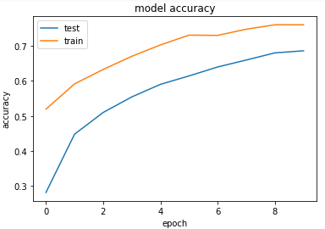
Fig 6: Gain Model

To validate the gain graph result, loss occurred in model is also plotted and shown as loss graph by using similar parameters.
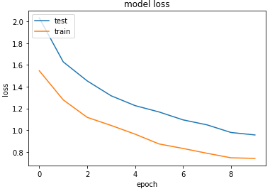
Fig 7: Loss Model

The optimum loss model for training and test set shows ANN algorithms efforts in reducing error rate in model.

VII. Conclusion & Future Works

The results obtained in these project and previous work done in sound classification hinted that area of unsupervised learning is dominating the fields of classification because of its reliability in getting same accuracy without usage of many methods. The evaluation results showed that project has successfully
achieved its goals in classifying source of sounds at
precise level and showed sensitivity of different labels. The only concern is getting more overlapped data so model can be trained more efficiently. Keeping the base of primitive work done in field the project highlighted that different classifiers predicted respective higher accuracy for different labels of sounds. Environmental sound scanning and classification is still concerned area as classifier underperformed in predicting class of sound source due to background noise in data. Areas need to be explore like noise of surrounding which will help in create a context aware classification for security purposes. More data of environmental areas with more sound factors will facilitate in improving efficiency of self-driving cars. Indirectly more complex data including lot of class and overlapped sound will help in redesigning neural network system to analyze the sound classification at micro level.

References

[1] S. Keydana, “TensorFlow for R_ Audio classification with Keras_ Looking closer at the non-deep learning parts,” 2019. [Online]. Available: https://blogs.rstudio.com/tensorflow/posts/2019-02-07-audio-background/.
[2] J. Salamon and J. P. Bello, “Unsupervised feature learning for urban sound classification,” ICASSP, IEEE Int. Conf. Acoust. Speech Signal Process. - Proc., vol. 2015–Augus, pp. 171–175, 2015.
[3] S. Allegro, M. Büchler, and S. Launer, “Automatic sound classification inspired by auditory scene analysis,” Consistent Reliab. Acoust. Cues Sound Anal. CRAC oneday Work. Aalborg Denmark Sunday Sept. 2nd 2001 directly before Eurospeech 2001, vol. 2005, no. 18, p. Vuegen, L., Broeck, B. Van Den, Karsmakers, P., Ge, 2001.
[4] V. Bountourakis, L. Vrysis, and G. Papanikolaou, “Machine Learning Algorithms for Environmental Sound Recognition: Towards Soundscape Semantics,” 2015.
[5] F. Briggs, X. Z. Fern, and J. Irvine, “Multi-Label Classifier Chains for Bird Sound,” vol. 28, 2013.
[6] P. Dhakal, P. Damacharla, A. Y. Javaid, and V. Devabhaktuni, “Detection and Identification of Background Sounds to Improvise Voice Interface in Critical Environments,” 2018 IEEE Int. Symp. Signal Process. Inf. Technol., pp. 078–083, 2019.
[7] M. Z. Anwar, Z. Kaleem, and A. Jamalipour, “Machine Learning Inspired Sound-based Amateur Drone Detection for Public Safety Applications,” IEEE Trans. Veh. Technol., vol. 68, no. 3, pp. 1–1, 2019.
[8] J. X. Low and K. W. Choo, “Classification of Heart Sounds Using Softmax Regression and Convolutional Neural Network,” pp. 18–21, 2018.

[9] X. Dong, N. Yan, and Y. Wei, “Insect Sound Recognition Based on Convolutional Neural Network,” 2018 3rd IEEE Int. Conf. Image, Vis. Comput. ICIVC 2018, pp. 855–859, 2018.
[10] K. Ko, S. Park, and H. Ko, “Convolutional Feature Vectors and Support Vector Machine for Animal Sound Classification,” Proc. Annu. Int. Conf. IEEE Eng. Med. Biol. Soc. EMBS, vol. 2018–July, pp. 376–379, 2018.
[11] Z. Ren, N. Cummins, V. Pandit, J. Han, K. Qian, and B. Schuller, “Learning Image-based Representations for Heart Sound Classification,” no. 143, pp. 143–147, 2018.
[12] G. Chambres, P. Hanna, and M. Desainte-Catherine, “Automatic detection of patient with respiratory diseases using lung sound analysis,” Proc. - Int. Work. Content-Based Multimed. Index., vol. 2018–Septe, 2018.
[13] I. Sen, M. Saraclar, and Y. P. Kahya, “A Comparison of SVM and GMM-Based Classifier Configurations for Diagnostic Classification of Pulmonary Sounds,” IEEE Trans. Biomed. Eng., vol. 62, no. 7, pp. 1768–1776, 2015.
[14] K. K. B, E. Putin, M. Balashov, and A. Filchenkov, “Artificial Neural Networks and Machine Learning – ICANN 2013,” vol. 8131, no. November, 2013.
[15] J. Ye, T. Kobayashi, and M. Murakawa, “Urban sound event classification based on local and global features aggregation,” Appl. Acoust., vol. 117, pp. 246–256, 2017.
[16] Y. Chen, Q. Guo, X. Liang, J. Wang, and Y. Qian, “Environmental sound classification with dilated convolutions,” Appl. Acoust., vol. 148, pp. 123–132, 2019.
[17] F. Saki and N. Kehtarnavaz, “Real-time hierarchical classification of sound signals for hearing improvement devices,” Appl. Acoust., vol. 132, no. November 2017, pp. 26–32, 2018.
[18] X. Zhang, Y. Zou, and W. Wang, “LD-CNN: A Lightweight Dilated Convolutional Neural Network for Environmental Sound Classification,” Proc. - Int. Conf. Pattern Recognit., vol. 2018–Augus, pp. 373–378, 2018.
[19] F. G. Nabi, K. Sundaraj, C. K. Lam, and R. Palaniappan, “Characterization and classification of asthmatic wheeze sounds according to severity level using spectral integrated features,” Comput. Biol. Med., vol. 104, no. October 2018, pp. 52–61, 2019.
[20] I. Ozer, Z. Ozer, and O. Findik, “Lanczos kernel based spectrogram image features for sound classification,” Procedia Comput. Sci., vol. 111, no. 2015, pp. 137–144, 2017.
[21] A. Yadollahi and Z. Moussavi, “Automatic breath and snore sounds classification from tracheal and ambient sounds recordings,” Med. Eng. Phys., vol. 32, no. 9, pp. 985–990, 2010.
[22] M. F. Hornick, E. Marcadé, and S. Venkayala, “‘Data Mining Process’, Java Data Mining,” Elsevier, pp. 51–83, 2007.
[23] E. Goel and E. Abhilasha, “Random Forest: A Review,” Int. J. Adv. Res. Comput. Sci. Softw. Eng., vol. 7, no. 1, pp. 251–257, 2017.
[24] Z. Liu, X. Lv, K. Liu, and S. Shi, “Study on SVM compared with the other text classification methods,” 2nd Int. Work. Educ. Technol. Comput. Sci. ETCS 2010, vol. 1, pp. 219–222, 2010.
[25] S. Tangkawanit, C. Pinthong, and S. Kanprachar, “Development of gunfire sound classification system with a smartphone using ANN,” 3rd Int. Conf. Digit. Arts, Media Technol. ICDAMT 2018, pp. 168–172, 2018.
[26] M. Sokolova and G. Lapalme, “A systematic analysis of performance measures for classification tasks,” Inf. Process. Manag., vol. 45, no. 4, pp. 427–437, 2009.
[27] S. Sharma, “Epoch vs Batch Size vs Iterations – Towards Data Science,” Towards Data Science. 2017.

IEEE conference templates contain guidance text for composing and formatting conference papers. Please ensure that all template text is removed from your conference paper prior to submission to the conference. Failure to remove template text from your paper may result in your paper not being publis

